**MCj02955960000[1]MCj02955960000[1]MCj02955960000[1]MCj02955960000[1]**

**2019 Westminster Baseball Association**

**Golf Tournament**

**HOLE SPONSOR FORM**

**Outing Date: Friday, April 26th, 2019**

**Location: The Links at Gettysburg**

Dear Sponsor,

Westminster Baseball Association would like to thank you for your generous contribution to our program. Contributors like you make it possible for the Westminster Baseball Association program to provide the youth of our community with the rewarding experiences of baseball in a fun and exciting way. Thank you again for your considerate donation.

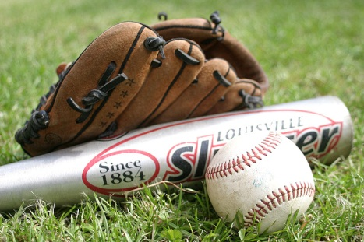Sincerely,

David Downs

[Golfdaj.wba.vp@gmail.com](mailto:Golfdaj.wba.vp@gmail.com)

410-218-2710

Doug Goodson

[dpgoodone@msn.com](mailto:dpgoodone@msn.com)

443-398-5501

**2019 Westminster Baseball Association Golf Tournament**

**Hole Sponsor $100**

Sponsor Name ________________________

Donation Amount ________________________

Pay online through **PayPal**: Choose the ‘Send to Friend’ option and send to [wbasecretary14@gmail.com](mailto:wbasecretary14@gmail.com). Please note in the comments section: Golf Hole Sponsor 2019 OR Checks can be made payable to WBA with this form and mailed to: WBA, PO Box 2008, Westminster, MD 21158.